Jerry Hu

ITWS 1100

Voice War: Hey Google vs. Alexa vs. Siri

10/16/2019

Voice War Case Study

The topic of voice assistants is getting more and more popular recently. State-of-art technology companies released their voice assistants one after another. Now, Amazon’s Alexa, Google Assistant and Apple’s Siri are leading this industry. Three companies compete with each other intensively and all want to be the final winner of this “Voice War”. From my perspective, to win the Voice War, the voice assistants need to have the following characteristics and now, Google seems to be best positioned.

First of all, what is voice assistants? According to Whatls.com, a voice assistant is a digital assistant that uses voice recognition, natural language processing and to assist users with tasks. (1) So, the primary goal of voice assistants is to assist users to let them do things more efficiently. If using a voice assistant cannot increase users’ efficiency of doing a task, It will not be a good voice assistant. Thus, the accuracy of receiving linguistic command, the processing speed and the functionality of a voice assistant will be the three major aspects to win the voice war.

In terms of the accuracy of the voice assistant, Google Assistant no doubt will be the No.1 voice assistant. According to ZDNet, investor analyst Loup Venture tested Amazon Alexa, Apple Siri, and Google Assistant 800 questions to figure out their accuracy. (2) The outcome shows that on the smart speakers exclusively, Google answered 88% of questions correctly, Apple scored 75% and Alexa scored 72.5%. When it comes to smartphones, Google Assistant’s accuracy even reaches to 92.9%. Siri’s accuracy is 83.1% of questions, while Alexa is 79.8%. 92.9% means that Google Assistant is nearly infallible. In daily life, if we want to listen to music, we usually choose to click on the screen instead of using the voice assistant is because it is unreliable. We need to speak out the command slowly and clearly and it may still get a chance to fail our command. Using voice assistant is much more time consuming than simply just click on the screen. But with Google's assistant, this concern seems to disappear.

The reaction speed is how long time it will process our data. Since 5G is about to release very soon, it is no point to use huge lengths to talk about which voice assistants have the fastest reaction speed now. I am sure that all of the voice assistants will improve their responding speed greatly when 5G is released. However, Google just invest a new mechanism to improve the responding speed of Google Assistant. (3) According to Google I/O, the next generation of the Google Assistant will perform near real-time transcription without an Internet connection.

The last important characteristic is the functionality. The voice assistant is an assistant. If everything you said it replies:” Sorry, I am unable to do that.” It will be a failed voice assistant. Here is a table to show why I think Siri is a dysfunctional voice assistant.

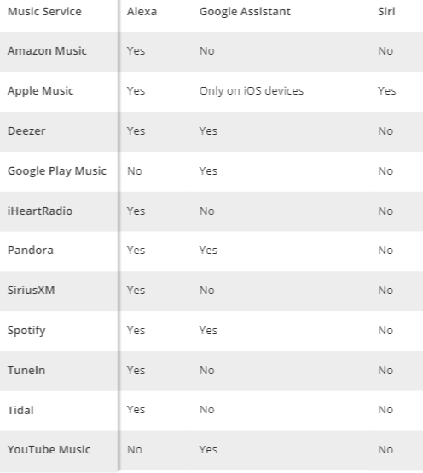

This table shows the supported music services of the three voice assistances. (4)

We can see that Siri’s functionality is too limited compared to Alexa and google assistant. The website Tom’s Guide also tested Google Assistant, Alexa, and Siri on other aspects, such as online shopping, ordering food, entertaining and navigation. In general, Google Assistant seems to have the most powerful and comprehensive functionality comparing to Alex and Siri. (4)

Bibliography:

1.

Title: voice assistant

URL: <https://whatis.techtarget.com/definition/voice-assistant>

Author: Margaret Rouse

Contributor: Matthew Haughn

Website: <https://whatis.techtarget.com/>

2.

Title: Apple Siri vs Amazon Alexa vs Google Assistant: Tests reveal which is smartest

URL: <https://www.zdnet.com/article/apple-siri-vs-amazon-alexa-vs-google-assistant-tests-reveal-which-is-smartest/>

Author: Liam Tung

Website: [https://www.zdnet.com](https://www.zdnet.com/)

3.

Title: Google Assistant response speed getting improved by on-device processing

URL: <https://appleinsider.com/articles/19/05/07/google-assistant-response-speed-getting-improved-by-on-device-processing>

Author: Malcolm Owen

Website: <https://appleinsider.com/>

4.

Title: Alexa vs. Google Assistant vs. Siri: Why Google Wins

URL: <https://www.tomsguide.com/us/alexa-vs-siri-vs-google,review-4772.html>

Author: Dan Moren

Website: <https://www.tomsguide.com/>